Square
Rectangle
Triangle
Parallelogram
Rhombus
Trapezium
Kite

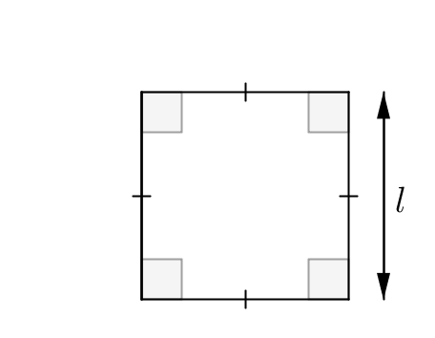  Formula: |   5m
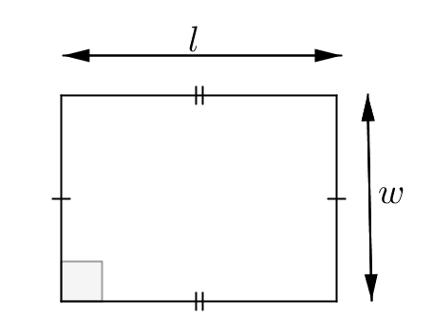  Formula: |   5cm  3cm
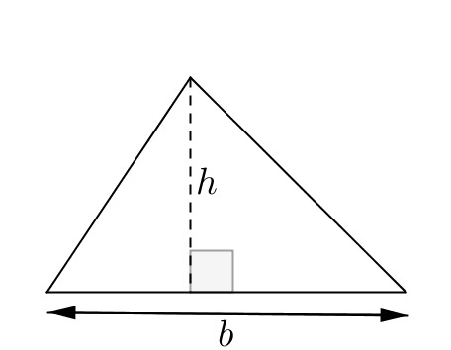  Formula: |   12m  10m
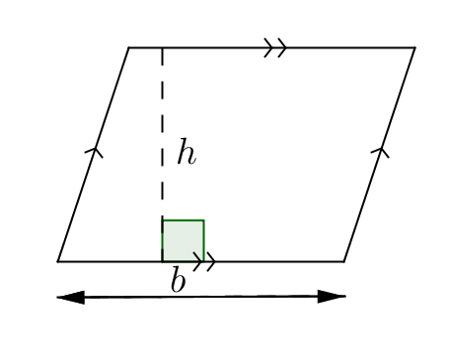  Formula: |   5m  6m
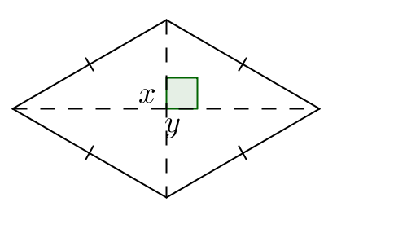  Formula: |   6m  5m
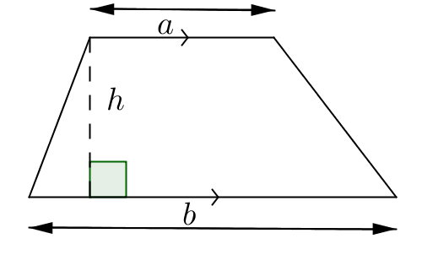  Formula: |   8m  4m  5m
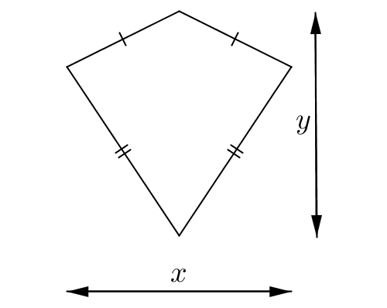  Formula: |   10m  8m

